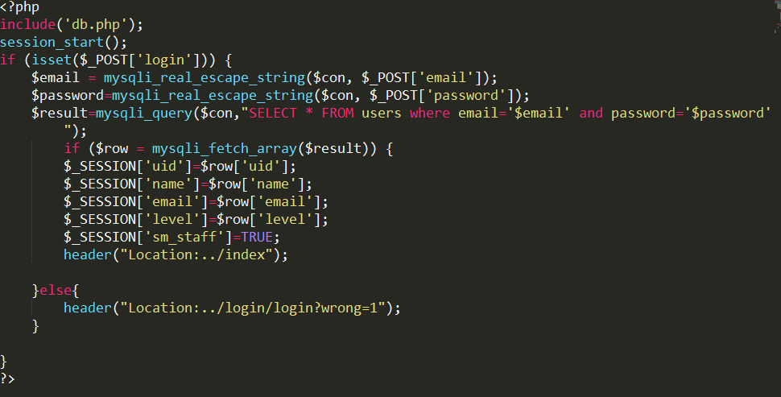

Figure User login Script

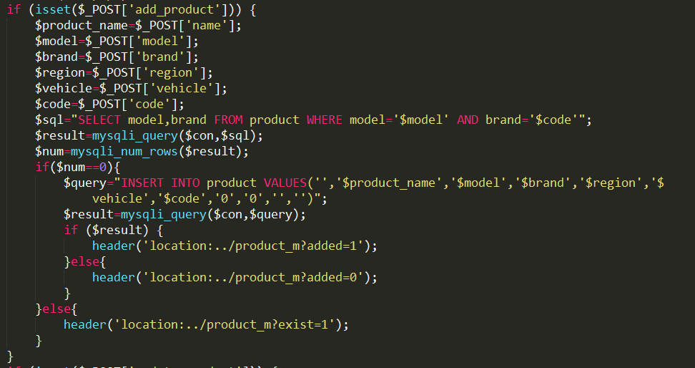

Figure Product Add Script

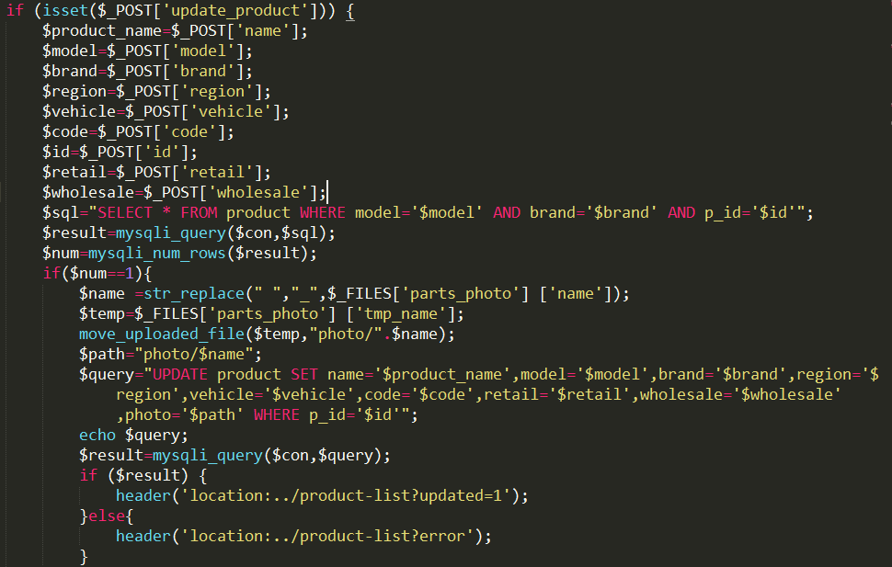

Figure Product Update Script

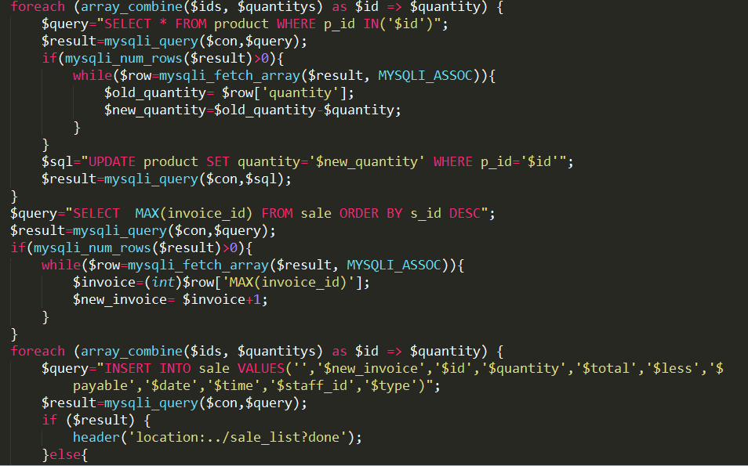

Figure Product Sale Script

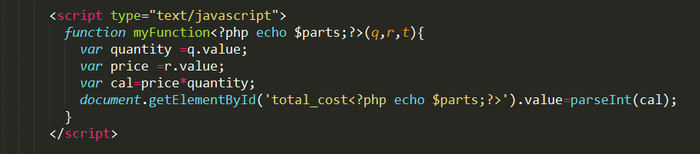

Figure JavaScript code for calculate product price

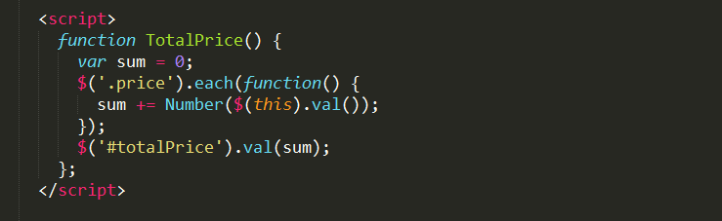

Figure Calculate total price of selected product

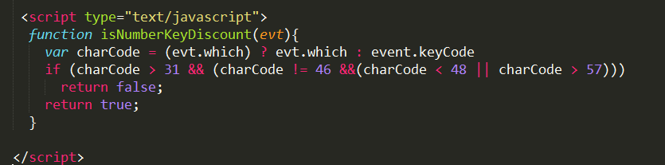

Figure JavaScript Code for prevent character input in specific input field.